**Task 4 - Creating a Prototype User Interface and Usability Testing**

**Function #1: Sign in Page**

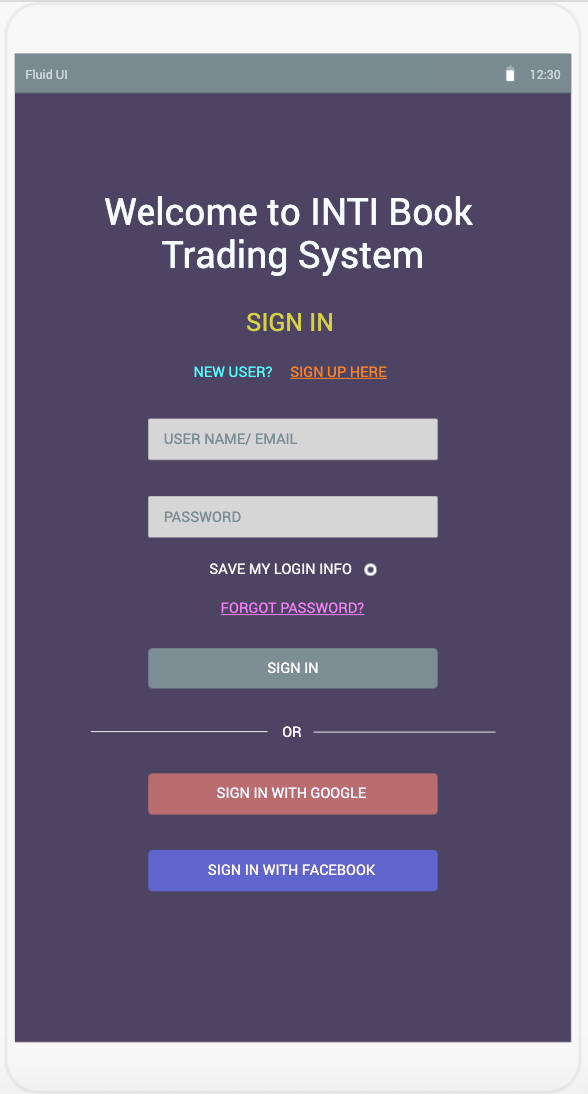

**Questions for Usability Testing:**

1. Please sign in using your account credentials, username: admin & password: 123.
2. Please sign in using your Google account.
3. Please sign in using your Facebook account.
4. Please register for as a new user on the book trading system.
5. Please reset your password in case of forget password.

**Function #2: Search and Homepage**

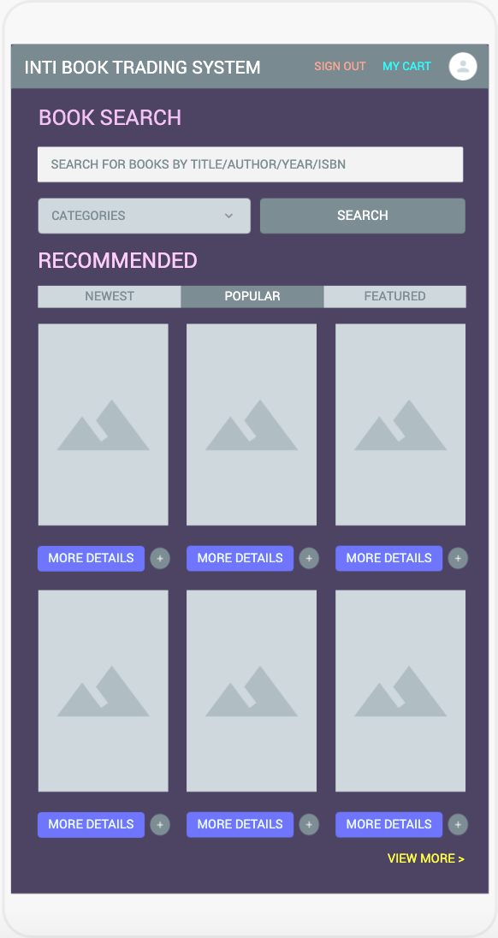

**Questions for Usability Testing:**

1. Please search for books under self-improvement category.
2. Please search for Statistics for Dummies by Deborah J. Rumsey.
3. Please search for a book with ISBN of 1913922413.
4. Please add any recommended books to your cart.
5. Please retrieve more details for one of the recommended books.